Core|Personnel: Training Module

Contents
Document Version Control 1
Approved process for raising 2
Consultation & Approval 2
Change Management 2
How to 3
Testing 4
Communications 4
Downstream Systems & Processes 4
Affected Reports 4
Additional Background Information 4

Document Version Control
Change History/Review Details
Date | Version | Review by | Summary of Change
26/06/2017 | 1.0 | Athena Artuso | Initial draft
19/07/2017 | 1.1 | Athena Artuso | Update to Additional Background Information
15 Jan 2019 | 1.2 | Helen Child | Further details added

Approved process for raising
Does the change need to be raised through a particular route or by a particular person/team? Are there any actions which need to be taken or considered prior to processing in the HRIS Support Centre?
A request could come from any user or potential user of the module. The request should be reviewed by the Business Process Adviser and HRIS trainer in the first instance.

Any changes must follow the Change Management process in force at the time of the change.

Consultation & Approval
Who is the owner of this information? Who needs to be consulted about this change before you begin work on it? Does anyone need to approve this change before it is implemented?
The HRIS Support centre is the owner of this module. However it is used by other departments. At the time this document was produced the module is used by the following:

OLI – Oxford Learning Institute
Bodleian Libraries

Change Management
What type of change is this? When should approval be sought and from whom (internal to team or change manager)? Who would normally be responsible for implementing?
The system changes must be approved by the System Owner (the Head of HRIS Support) or their nominated deputy, via the change request in HEAT, ideally before implementation.

How to
Technically how to process the change in the system
Adding a
Changing a
Removing a
Standard Icons & Terminology
Standard Button Names  Enter Query button:  Previous Record button:  Previous Section button:  Save button:  Insert Record button: | Execute Query button:  Next Record button:  Next Section button:  LOV button:  Delete Record button: | Cancel Query button:  Red Door button:  Duplicate Record button:
Navigation Paths

Show the final navigation path option in bold+italics, for example;

Core|Personnel > Reference > Reference A – C > Accident Codes
Core|Pay > Reference > Pay Groups

Any further navigation beyond the navigation path can be added after an ellipsis (…), for example;

Event Management > Event Configuration … HR Events > Change of Address

Testing
Who would normally be responsible for testing? Are there standard items to test?
The HRIS Analysis team and the HRIS Trainer are responsible for testing any changes to aspects of the Training Module.

Communications
Who needs to be informed (but not consulted) about this change? Detail when they should be informed (before or after the change).
The HRIS Trainer should be informed of any changes to the Training module and any other departments who use the training module e.g. OLI

Downstream Systems & Processes
Details of any processes which are affected or need to be carried out following, or as part of, the change. Please detail any triggers, actions required and when the actions should be carried out.
QRGs may need to be updated to reflect the changes.

Affected Reports
Are there any standard reports which may need to be updated following this change?
There are a number of reports run from The Training Module. These will need to be reviewed and updated if applicable.

Additional Background Information
Any other relevant information, links to supporting documentation etc.
The training module is not widely used and at present is only used by the HRIS Support Centre, Oxford Learning Institute and the Bodleian Libraries. In the past it has also been used by the Ashmolean Museum and UAS Finance but it is not clear whether these last two are still actively using the module.

Quick reference guides on the use of the module can be found at AA V20\Department\QRGs\Training Admin.

Within the Course Detail screen for any training course, there is a flag for “All Personnel” which indicates whether this course should be attended by all staff. This flag must remain unticked for all courses. This refers to all personnel within the entire organisation i.e. the University of Oxford and it is highly unlikely that any course will apply to every employee. Ticking this box triggers actions that we do not want implemented.

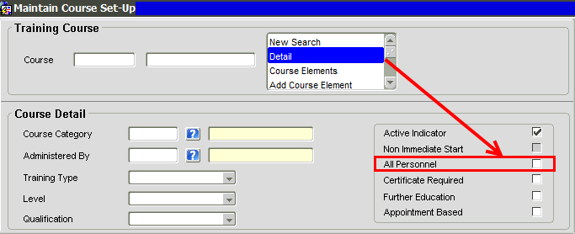

If the “All Personnel” flag is ticked for a course, the Training Module will insert a dummy qualification in the Personal Profile > Qualification Details screen of each employee who has completed the course. See HEAT Incident #10373713 for an example of this.

